Program Cover Sheet

|  |
| --- |
| Name: Adam Cossin |
| Assignment: Assignment 6 |
| List any parts of the assignment that do not work/were not completed:  Could not figure out why, when closing the main form with child forms open, it will prompt if you want to close the first child twice if you hit ‘No’ the first time. For example, it will say ‘Are you sure you want to close EVM – 1’ and if you click ‘No’ the first time, it will prompt again for that child form, but will not do so for any other children, just the first. |

|  |
| --- |
| Instructor’s Comments: |
| Grade: |

Program Submission Requirements: (1) all files, zipped and uploaded to Canvas and (2) a completed cover sheet, program execution screenshots and source code printed, **stapled** and turned in during class. Failure to follow the submission requirements will result in points lost on that particular assignment.

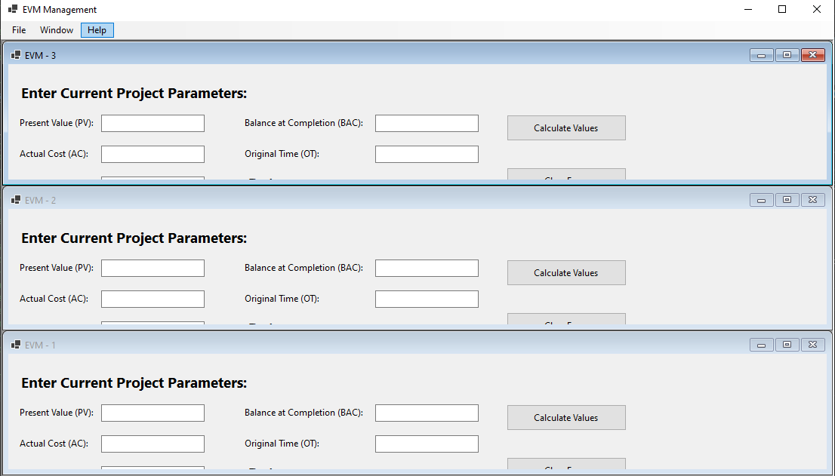

^Horizontal alignment

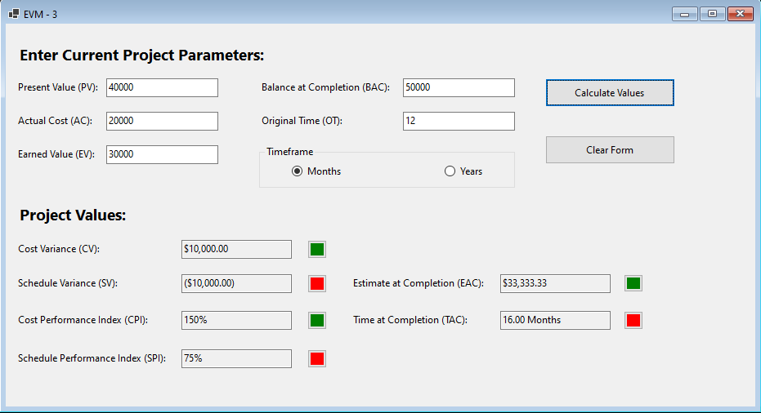

^Example of working page

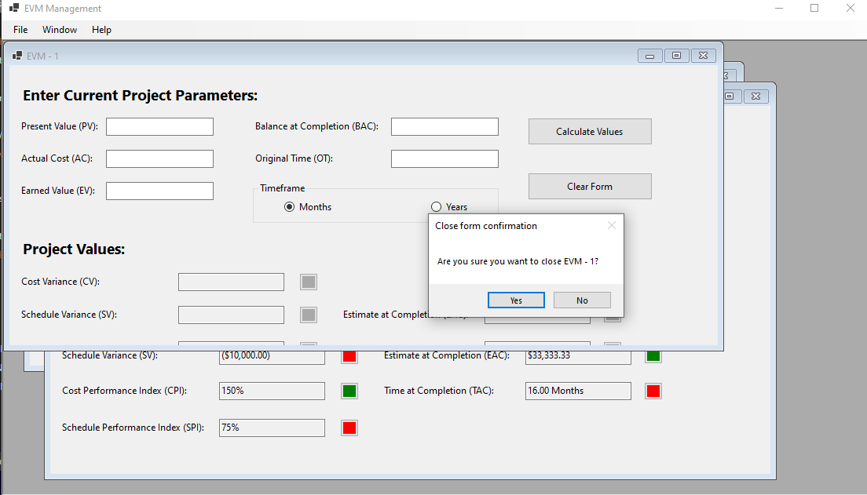

^Example closing message